

**Time Entry System**

**Design Document**

Author: Joseph F. Cadiao

XRM Software Developer

Tuesday, October 6, 2015

# Privacy information

This document contains information of a sensitive nature and is an intellectual property of Gurango Software Corporation. This information should not be given to persons other than those who are involved with this system/project or who will become involved during its lifecycle.

|  |  |
| --- | --- |
| **Copyright** | Manual copyright © 2015 Gurango Software Corporation. All rights reserved.  Your right to copy this documentation is limited by copyright law and the terms of the software license agreement. As the software licensee, you may make a reasonable number of copies or printouts for your own use. Making unauthorized copies, adaptations, compilations, or derivative works for commercial distribution is prohibited and constitutes a punishable violation of the law. |
| **Warranty disclaimer** | Gurango Software Corporation disclaim any warranty regarding the sample code contained in this documentation, including the warranties of merchantability and fitness for a particular purpose. |
| **Limitation of liability** | The content of this manual is furnished for informational use only, is subject to change without notice, and should not be construed as a commitment by Gurango Software Corporation and assume no responsibility or liability for any errors or inaccuracies that may appear in this manual. Neither Gurango Software Corporation nor anyone else who has been involved in the creation, production or delivery of this documentation shall be liable for any indirect, incidental, special, exemplary or consequential damages, including but not limited to any loss of anticipated profit or benefits, resulting from the use of this documentation or sample code. |
| **License agreement** | Use of this product is covered by a license agreement provided with the software product. If you have any questions, please call the Gurango Software Corporation at (+63) 637-0928. |
| **Publication date** | Tuesday, October 6, 2015 |

# Revision History

|  |  |  |  |  |  |
| --- | --- | --- | --- | --- | --- |
| Version | Date | Location of Change | A  M  D | Detail Description of Change [Author] | Change Request Number |
| 1.0 | 9/29/2015 |  | A | Initial draft |  |
| 1.0 | 9/30/2015 |  | M | Updated details in Architecture and Data Design |  |
| 1.0 | 10/1/2015 |  | M | Updated details in Component Design |  |
|  |  |  |  |  |  |
|  |  |  |  |  |  |
|  |  |  |  |  |  |
|  |  |  |  |  |  |
|  |  |  |  |  |  |
|  |  |  |  |  |  |
|  |  |  |  |  |  |
|  |  |  |  |  |  |
|  |  |  |  |  |  |
|  |  |  |  |  |  |
|  |  |  |  |  |  |
|  |  |  |  |  |  |
|  |  |  |  |  |  |
|  |  |  |  |  |  |
|  |  |  |  |  |  |
|  |  |  |  |  |  |
|  |  |  |  |  |  |
|  |  |  |  |  |  |
|  |  |  |  |  |  |
|  |  |  |  |  |  |
|  |  |  |  |  |  |
|  |  |  |  |  |  |
|  |  |  |  |  |  |
|  |  |  |  |  |  |
|  |  |  |  |  |  |
|  |  |  |  |  |  |
|  |  |  |  |  |  |
|  |  |  |  |  |  |
|  |  |  |  |  |  |
|  |  |  |  |  |  |
|  |  |  |  |  |  |
|  |  |  |  |  |  |
|  |  |  |  |  |  |

*A = Added M = Modified D = Deleted

# Table of Contents

Privacy information 2

Revision History 3

Table of Contents 4

Table of Figures 7

1. Introduction 8

1.1. Purpose 8

1.2. Scope 8

1.3. References 8

1.3.1. System Definitions, Symbols, Acronyms and Abbreviations 8

1.3.2. Document Archive Location(s) 8

2. Dependencies, Limitations, Constraints and Prerequisites 9

2.1. Hardware Requirements Used to Develop the Product 9

2.2. Software Requirements Used to Develop the Product 9

3. System Overview 10

3.1. Architectural Design 10

4. Data Design 11

4.1. Data Flow Diagram 11

4.2. Entity Relationship Diagram 11

4.2. Data Dictionary 11

5. Component Design 12

5.1. UML Class Diagram 11

# Table of Figures

# Introduction

## Purpose

The purpose of this document is to help the clients and developers understand how the project was designed and created. This technical documentation will be a reference whenever a person will administer the maintenance or modification of the Time Entry System. Clients will also have an idea on how the system interacts with end-users and how other components of the system work together, using high-level diagrams presented in this document.

## Scope

The documentation includes overview of the system, architectural design, data design, component design, requirements for an organization to run the system, and high-level overview of how each components of the system work together.

## References

### System Definitions, Symbols, Acronyms and Abbreviations

|  |  |
| --- | --- |
| CODE | DEFINITION |
| MS CRM | Microsoft Customer Relations Management |
| API | Application Programming Interface |
|  |  |
|  |  |
|  |  |
|  |  |
|  |  |
|  |  |

# Dependencies, Limitations, Constraints and Prerequisites

## Hardware Requirements Used to Develop the Product

|  |  |
| --- | --- |
| PARTICULARS | DESCRIPTION (relation to the product) |
| System Unit | I3 4th Gen, 4GB RAM |
|  |  |
|  |  |
|  |  |
|  |  |
|  |  |
|  |  |

## Software Requirements Used to Develop the Product

|  |  |
| --- | --- |
| PARTICULARS | DESCRIPTION (relation to the product) |
| Visual Studio 2013 | .NET IDE Platform |
| Microsoft CRM Online 2015 |  |
| Windows Server 2012 |  |
| IIS 8 |  |
|  |  |
|  |  |
|  |  |

# System Overview

## Architectural Design

High-Level Acrchitecture:

The Diagram shows N-Layered architecture with their respective assembly (*AppContext, Models, TE_System Web App*). AppContext is a *Data Access Layer*, it basically retrieves data using the CRM API. Models is our *Business Object / Business Model Layer* that represents our data from the Entities in the CRM and TE_System Web Application is our *Presentation Layer* that represents our business models and its data, it is the layer that interacts and responds to end user’s request.



MS CRM

TES Web Application *Presentation Layer*:

MS CRM

App Context

Models



This diagram shows how the presentation layer interacts with the end user. So whenever a user does something that interacts with the server, the controller responds to it. The controller then calls the appropriate model and view that will be display to the end user. So if a user asks for the list of entry for a week the controller then asks the AppContext to get the data from the CRM API and return the values needed, and store it to the model which is binded to a specific view that the controller pushes to a user.

# Data Design

## Data Flow Diagram

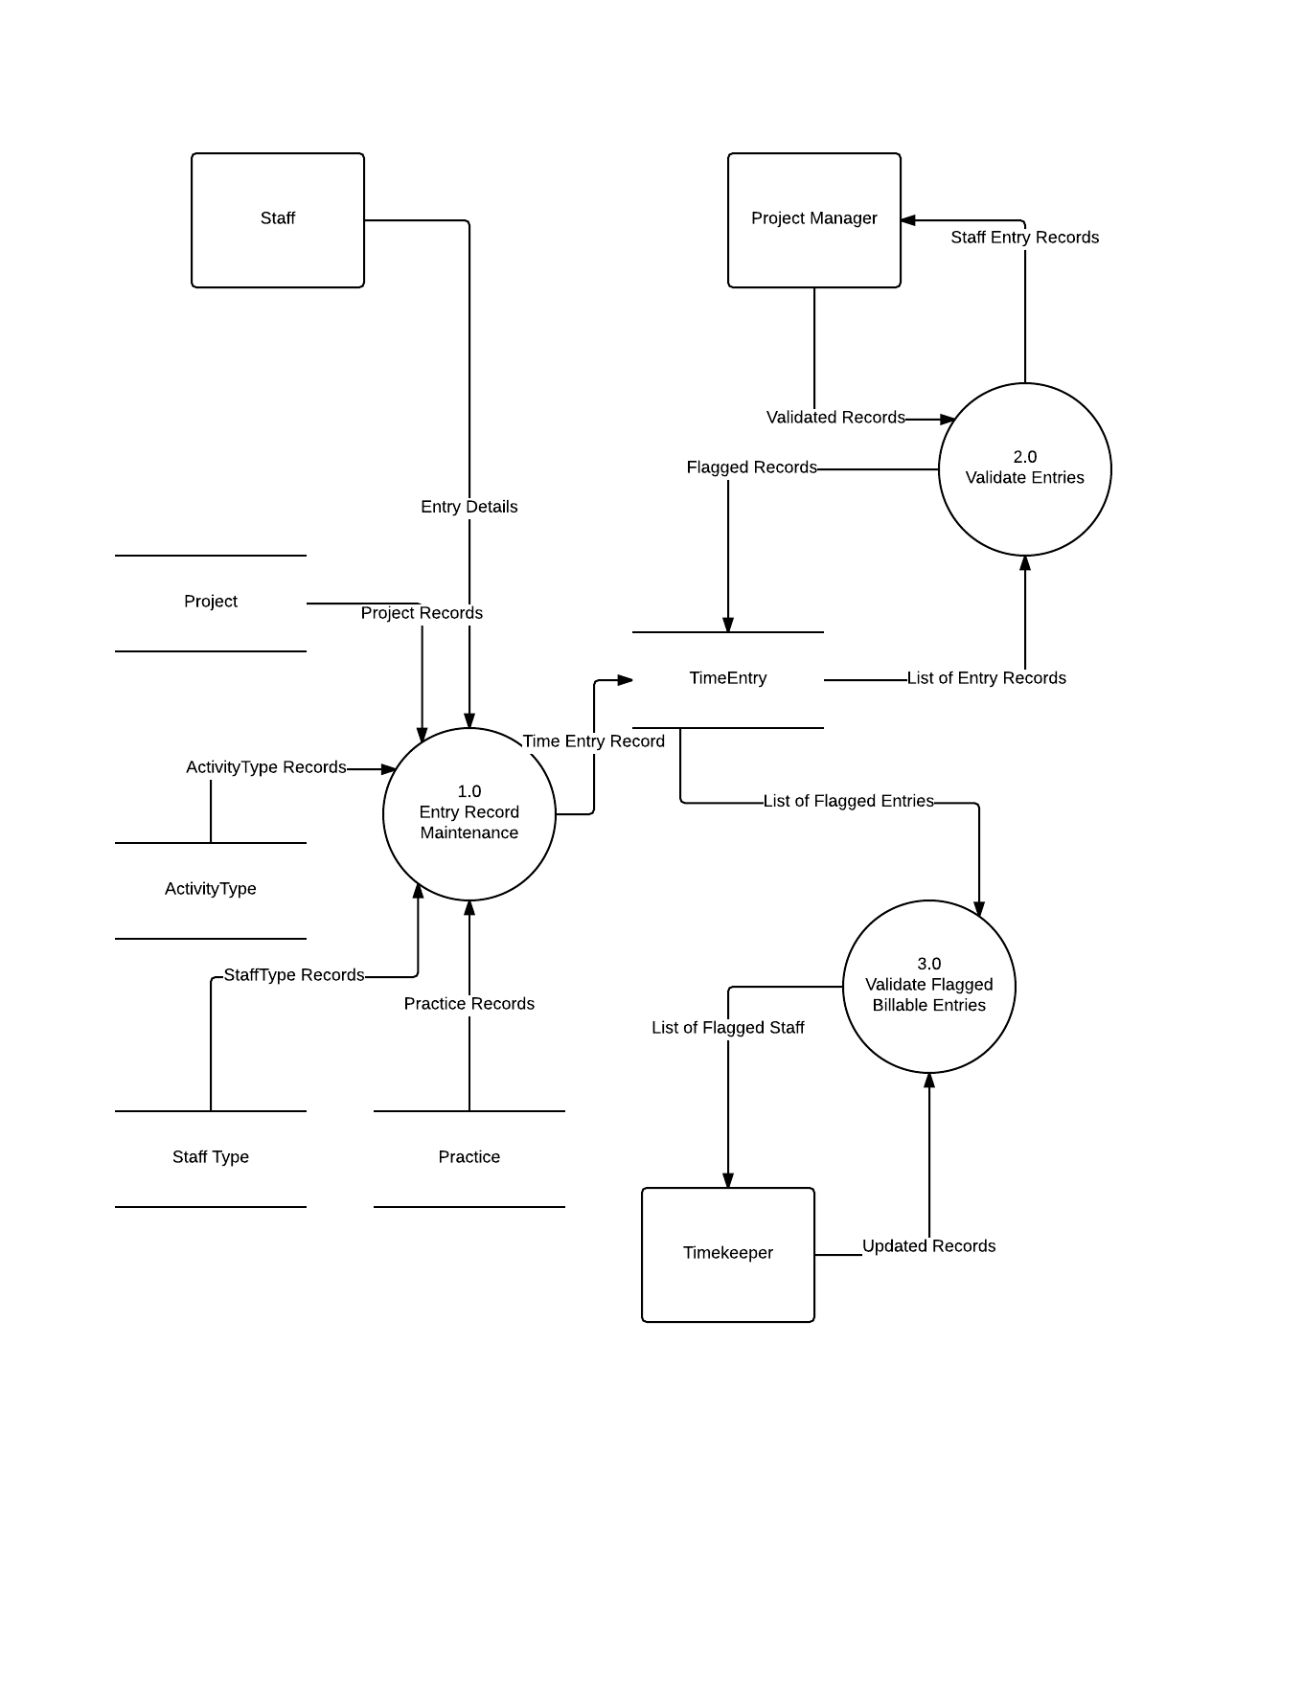

The diagram shows how the data flows within the system. We have 3 external entities, the Staff which enters a record for their activities, the Manager that validates those records and flags either a staff or timekeeper respectively and the Timekeeper which updates a billable record that has been flagged by the manager for validation.

## Entity relationship Diagram

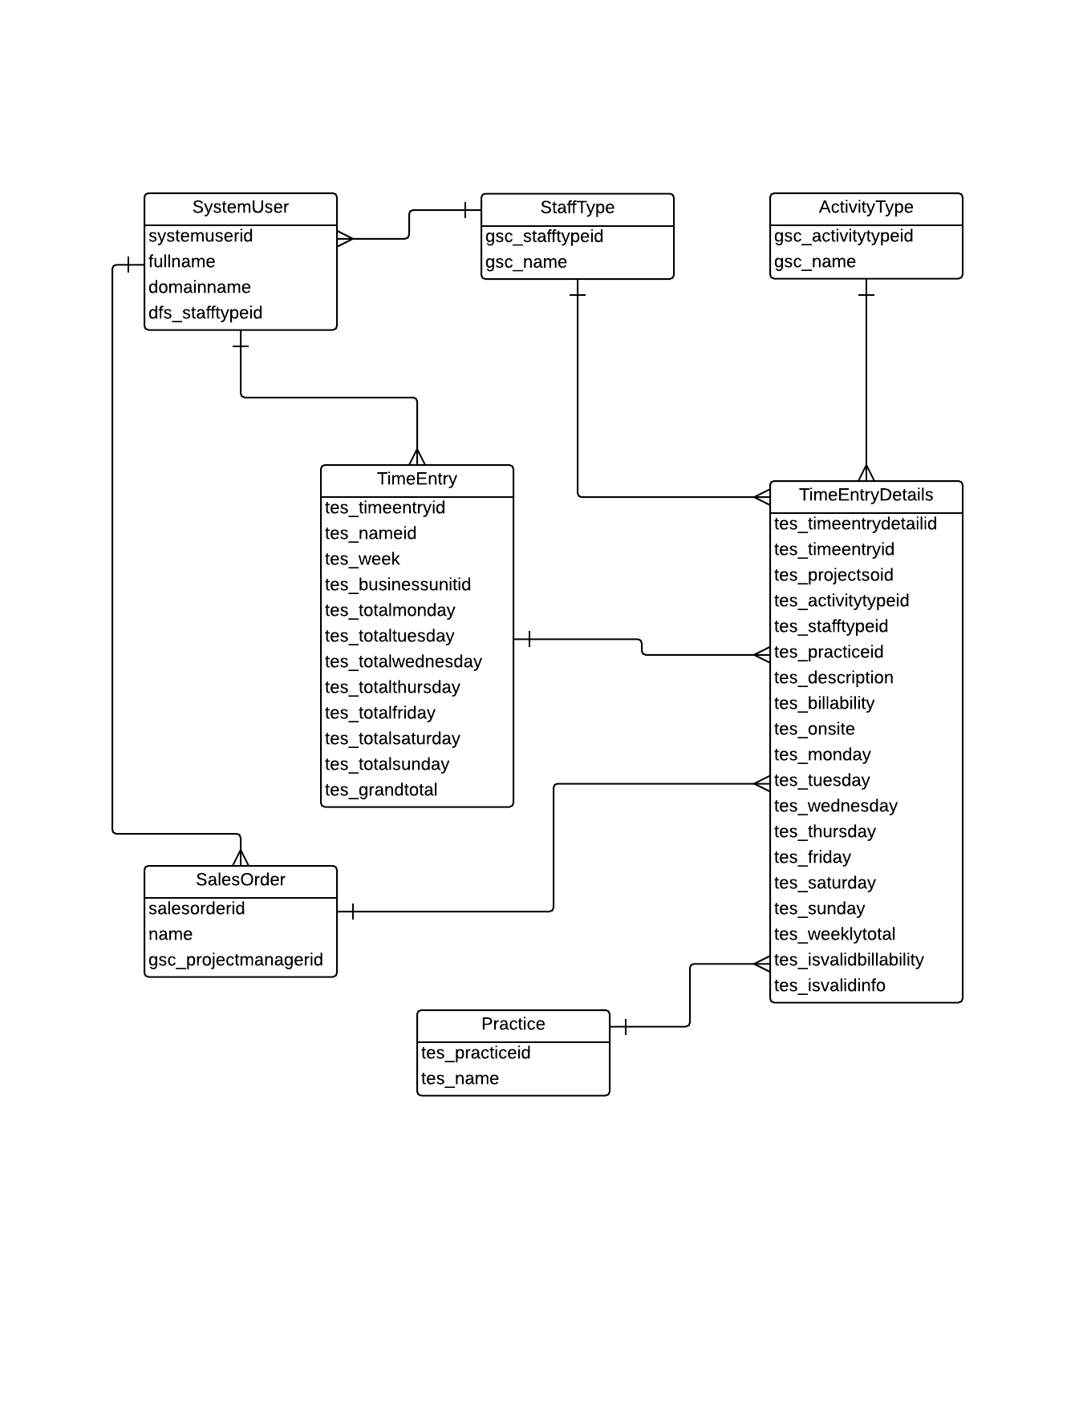

## Data Dictionary

**Entity Name: Time Entry Detail**

|  |  |  |
| --- | --- | --- |
| Field Name | Data Type | Description / Other Information |
| tes_timeentrydetailid | Unique identifier | Primary key |
| tes_timeentryid | Unique identifier | Foreign key. Entity Reference for Time Entry. |
| tes_projectsoid | Unique identifier | Foreign key. Entity Reference for Service Order. |
| tes_practiceid | Unique identifier | Foreign key. Entity Reference for Practice. |
| tes_activitytypeid | Unique identifier | Foreign key. Entity Reference for Activity Type. |
| tes_stafftypeid | Unique identifier | Foreign key. Entity Reference for Staff Type. |
| tes_activitydescription | Nvarchar (100) | Description for every project activity |
| tes_billability | Boolean | Indicates whether this record is billable or not |
| tes_onsite | Boolean | Indicates whether the activity was in premise or not |
| tes_monday | Decimal(10, 2) | Rendered hours for monday |
| tes_tuesday | Decimal(10, 2) | Rendered hours for tuesday |
| tes_wednesday | Decimal(10, 2) | Rendered hours for wednesday |
| tes_thursday | Decimal(10, 2) | Rendered hours for thursday |
| tes_friday | Decimal(10, 2) | Rendered hours for friday |
| tes_saturday | Decimal(10, 2) | Rendered hours for saturday |
| tes_sunday | Decimal(10, 2) | Rendered hours for sunday |
| tes_weeklytotal | Decimal(10, 2) | Total rendered hours for the entry |
| tes_isvalidinfo | Boolean | Indicates whether the entry was flagged by the project manager for its content. |
| tes_isvalidbillability | Boolean | Indicates whether the entry was flagged by the project manager for its billability. |

**Entity Name: Time Entry**

|  |  |  |
| --- | --- | --- |
| Field Name | Data Type | Description / Other Information |
| tes_timeentryid | Unique identifier | Primary key |
| tes_nameid | Unique identifier | Foreign key. Entity Reference for System User. |
| tes_businessunitid | Unique identifier | Foreign key. Entity Reference for Business Unit. |
| tes_week | Integer | Week number of the entry. |
| tes_monday | Decimal(10, 2) | Total Rendered hours for monday |
| tes_tuesday | Decimal(10, 2) | Total Rendered hours for tuesday |
| tes_wednesday | Decimal(10, 2) | Total Rendered hours for wednesday |
| tes_thursday | Decimal(10, 2) | Total Rendered hours for thursday |
| tes_friday | Decimal(10, 2) | Total Rendered hours for friday |
| tes_saturday | Decimal(10, 2) | Total Rendered hours for saturday |
| tes_sunday | Decimal(10, 2) | Total Rendered hours for sunday |
| tes_weeklytotal | Decimal(10, 2) | Total rendered hours for the week. |

**Entity Name: Activity Type**

|  |  |  |
| --- | --- | --- |
| Field Name | Data Type | Description / Other Information |
| gsc_activitytypeid | Unique identifier | Primary key |
| gsc_name | Nvarchar (100) | Description / Name of an Activity |

**Entity Name: Staff Type**

|  |  |  |
| --- | --- | --- |
| Field Name | Data Type | Description / Other Information |
| gsc_activitytypeid | Unique identifier | Primary key |
| gsc_name | Nvarchar (100) | Description / Name of a Staff Type |

**Entity Name: Sales Order**

|  |  |  |
| --- | --- | --- |
| Field Name | Data Type | Description / Other Information |
| salesorderid | Unique identifier | Primary key |
| name | Nvarchar (100) | Description / Name of a Sale |
| gsc_projectmanagerid | Unique identifier | Foreign key. Entity Reference for System User. |

**Entity Name: Practice**

|  |  |  |
| --- | --- | --- |
| Field Name | Data Type | Description / Other Information |
| tes_practiceid | Unique identifier | Primary key |
| tes_name | Nvarchar (100) | Description / Name of a Practice |

**Entity Name: SystemUser**

|  |  |  |
| --- | --- | --- |
| Field Name | Data Type | Description / Other Information |
| systemuserid | Unique identifier | Primary key |
| fullname | Nvarchar (100) | Description / Name of a Practice |
| domainname | Nvarchar (100) | Description / Name of a Practice |
| gsc_stafftypeid | Unique identifier | Foreign key. Entity Reference for Business Unit. |

# Component Design

UML Class Diagram (AppContext):

**

UML Class Diagram (Model):



UML Class Diagram (TES Web App):

**